
SYSTEMS ANALYSIS PROJECT HW6
Yiğit Güleryüz 9A210028 REST
Harun Enes Oğuz 9A220011 MOBILE APP E COMMERCE SITE
Kerem İnan 9A210032
Enes Dikmen 9A210027**
Asil Gündüz 9A210088 PAPER FORM
Can Çoral 9A190036**

07 Ocak 2025
Medipol UNV

ENES DİKMEN DID NOT CONTRIBUTE
CAN ÇORAL DID NOT CONTRIBUTE

DESIGNING EFFECTIVE OUTPUT
1.Hard Copy Outputs
a. Internal Use
Revenue reports from the finance department for team management, merchandise and commerce sales and ticket sale earning reports.
b. External Use
Season pass(kombine) memberships and normal tickets.

2.Soft Copy Outputs
Notifications from app.
Infographics show fan statistics and match performance.
Real time team dashboard.

Green IT Initiative
Reducing hard copy output such as paper prints for reports. Use digital formats like PDFs.
In-app digital tickets.
Optimization of server usage.

Web Page and Input Screens
- Fan Registration screen for collecting personal details for membership registration.
Personal Details, Adress, Payment Info will be included.
- Ticket booking screens to allow users to book match tickets.
Match Selection, Seat Details and Stadium View Selection will be included
- Merchandise Buying System toll et users purchase club merchandise.
Product Info, Cart Summary, Shipping Details and Payment Details.

Mobile App Design
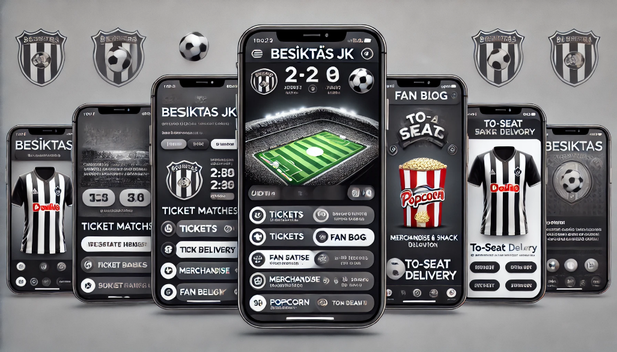
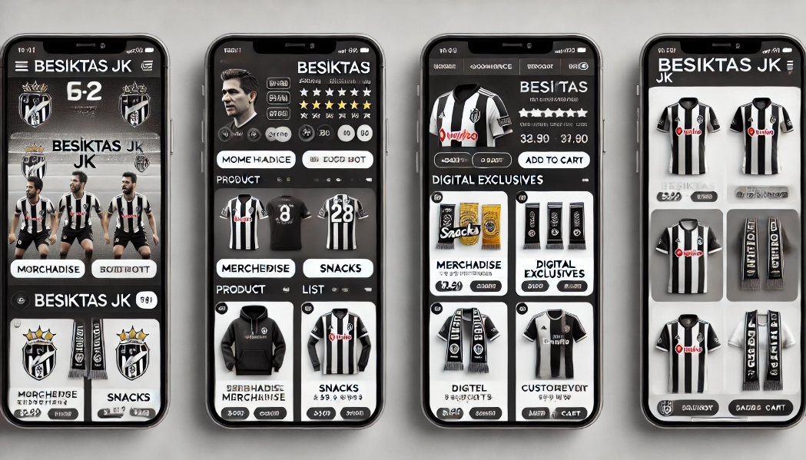

!! This Picture is made by ai to get ideas about it. It is not REAL!!
Features
- Home Screen
- Tickets
- Orders
- Fan Blog
- Profile
Input Screens
- Login/Registration:
- Ticket Purchase:
- Orders:
- Fan Blog:
- Profile:

DESIGNING EFFECTIVE INPUT
We planned a website for our Besiktas App. This website has the same features as our mobile app. We added some fill-in form inputs, register and login screens and ticket selection screens and payment screen and user-feedback form.
Paper Form
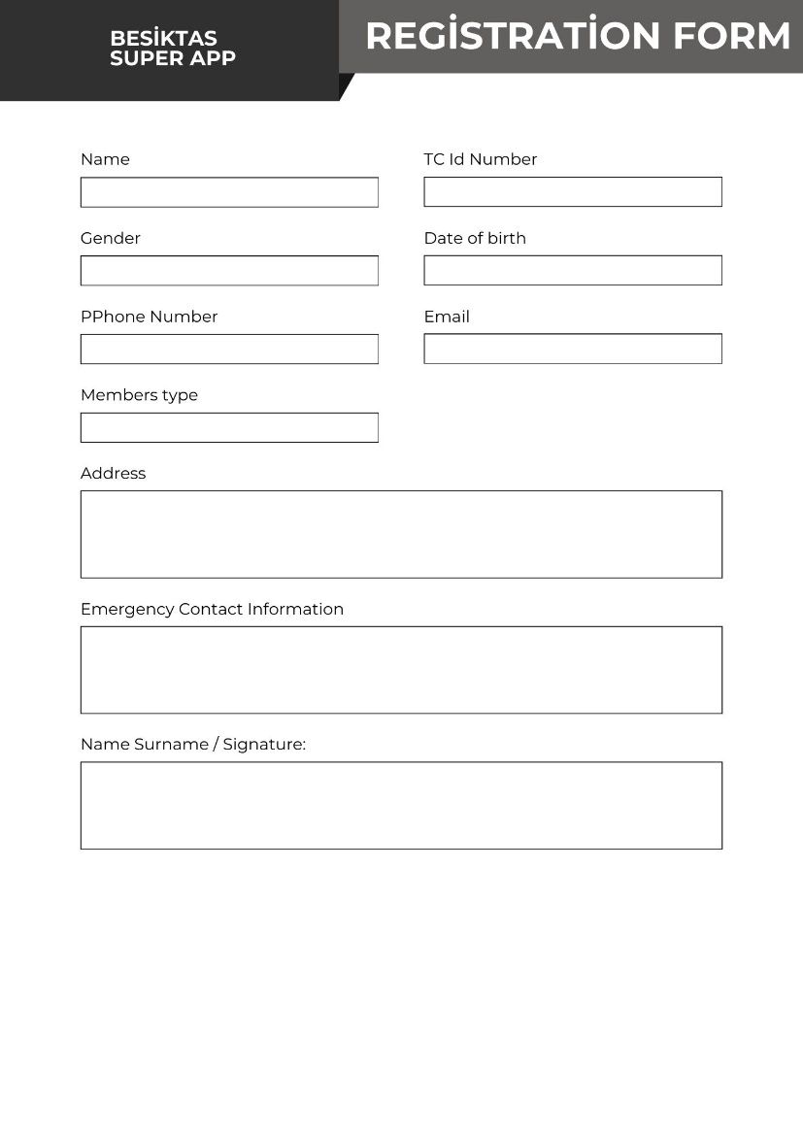

Web Based Fill-in Form
We sent the web based form extra. We liked it that way. It has all the feedback info needed. People can give their feedback about the app.

GUI EXAMPLE
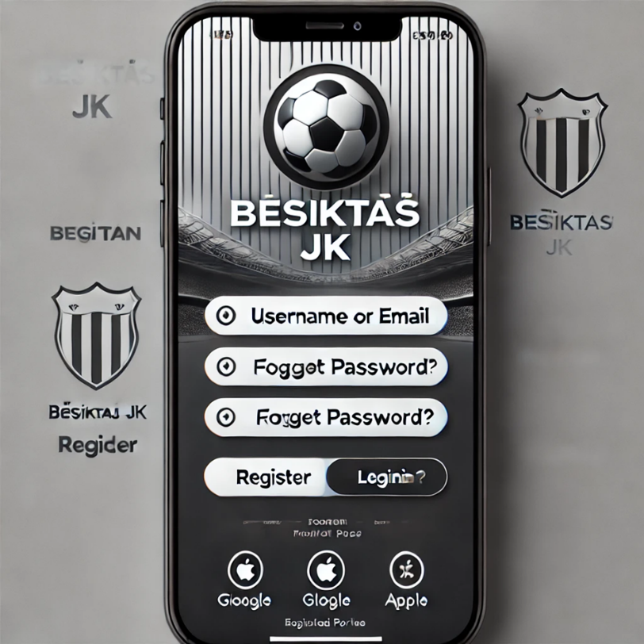
THIS IS NOT REAL EXAMPLE. IT IS AI!!

E-COMMERCE OPPORTUNITY
Besiktas App has a significant opportunity to integrate into an e commerce platform to make bigger revenue and fan engagement. The commerce platform will feature jerseys, scarves, T-shirts, hats, collectibles with match-day purchases. By focusing on e commerce size, it will strengthen the club’s brand and fan connection while increasing revenue.

Login Screen- E-commerce Web Page

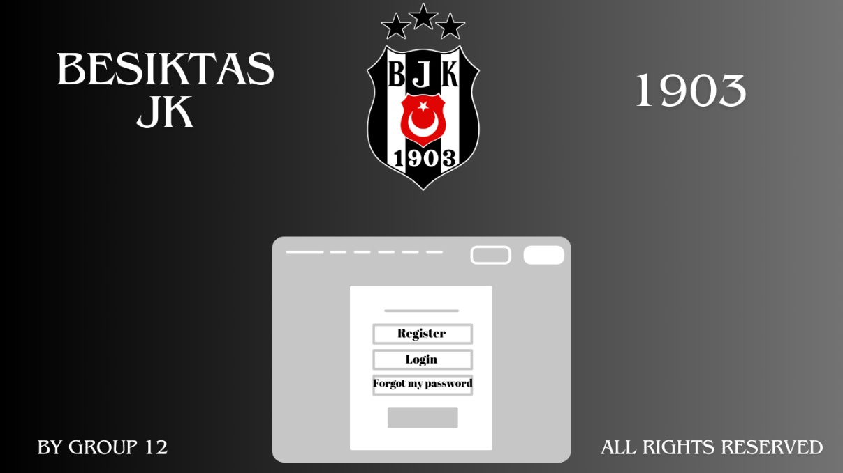
This screen will make users connect to their own accounts so they can see their purchases.
Purchase Screen – E commerce web page
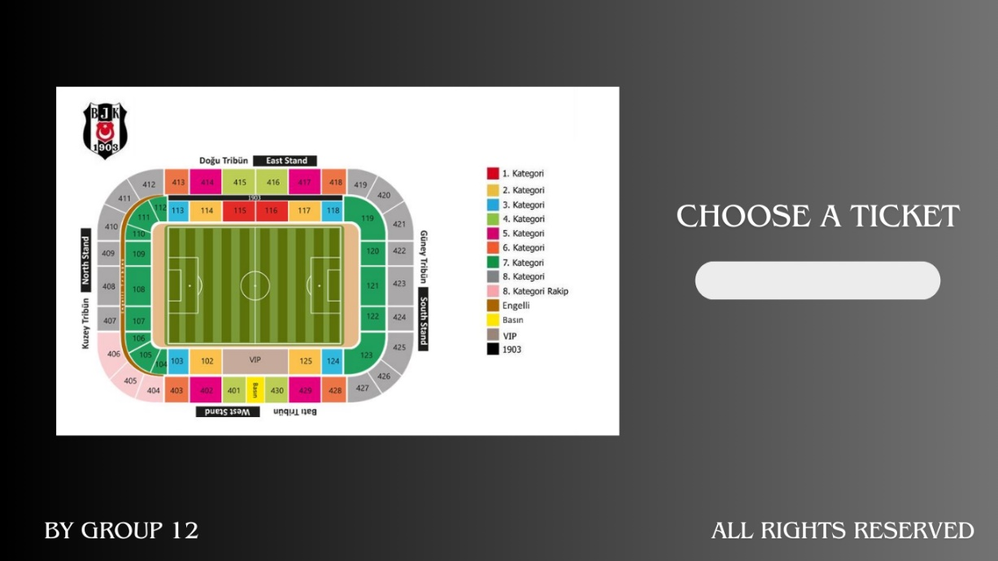
This screen is where users can use drop boxes to choose tickets

Payment Screen- E commerce web page
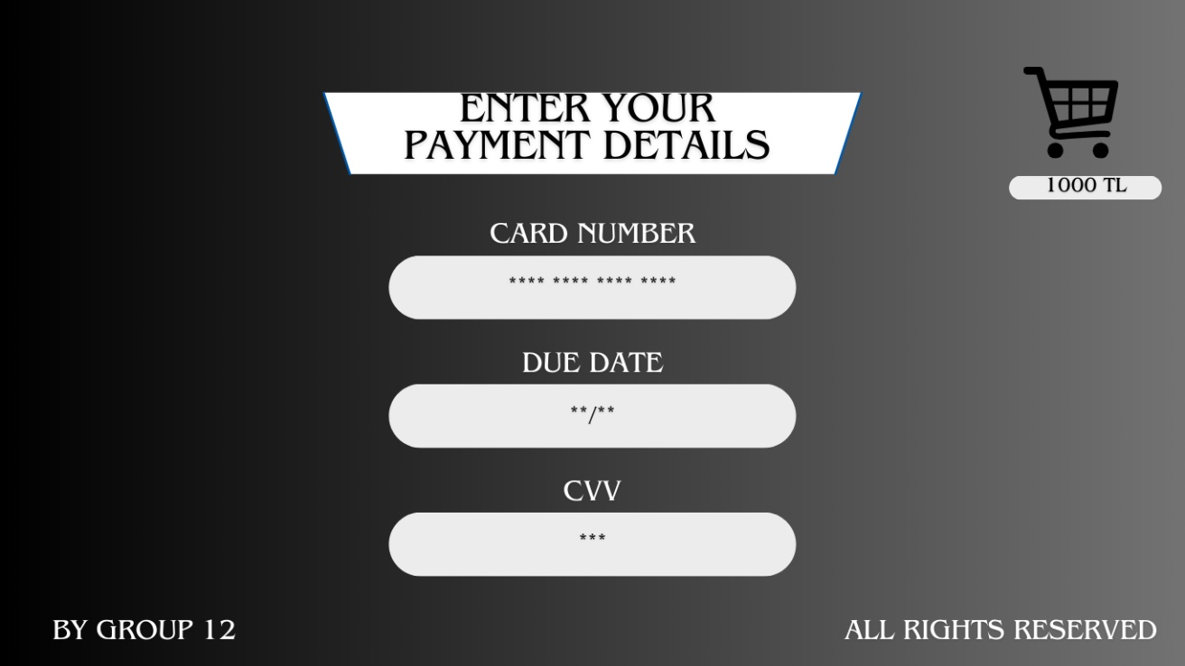
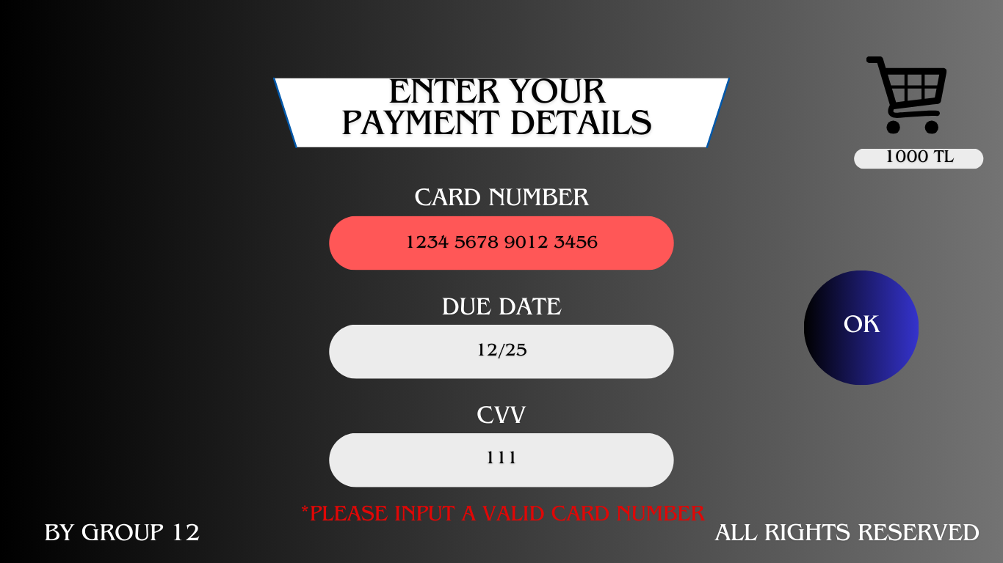

In this screen people will use their credit cards to buy merchandise.

